**Auto wiring Document**

**POD - 3**

**Online Grocery Store**

Riya Dighe – 2065747

Marrivada Sai Kavya - 2065919

Vaibhav Shetty - 2065774

Mittapally Sumanth - 2065743

Teja Mani - 2066007

**User :**

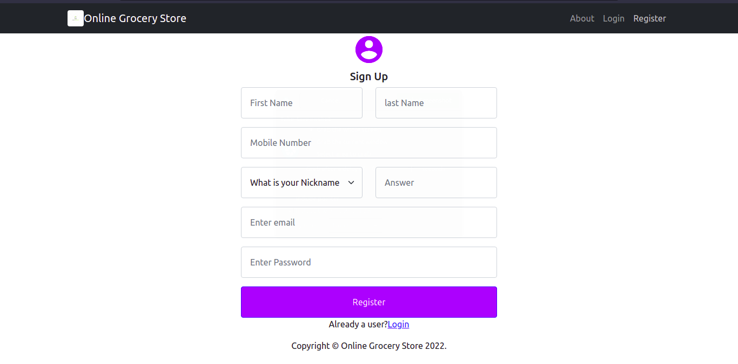

Figure 1. Sign up

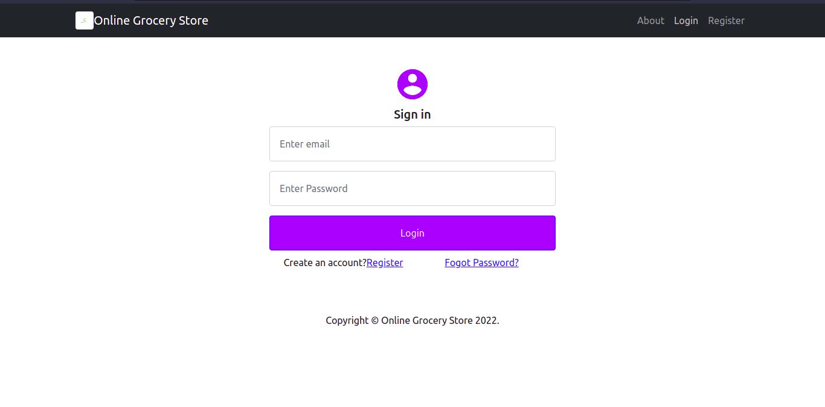

Figure 2. Login

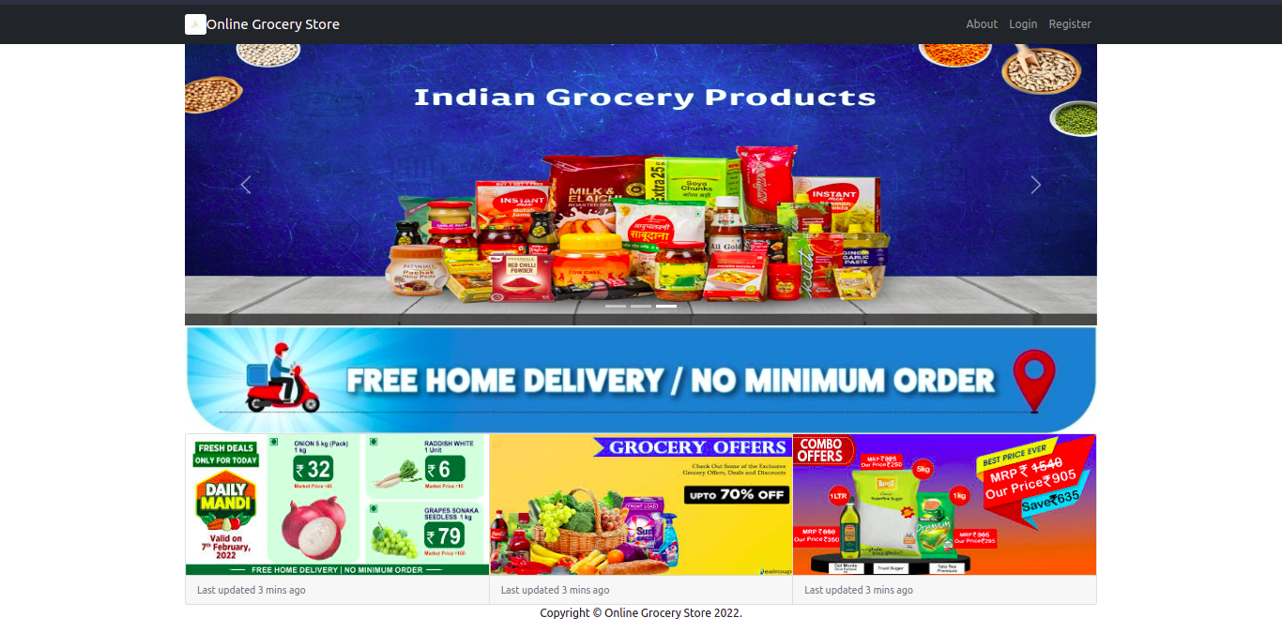

Figure 3. Home Page

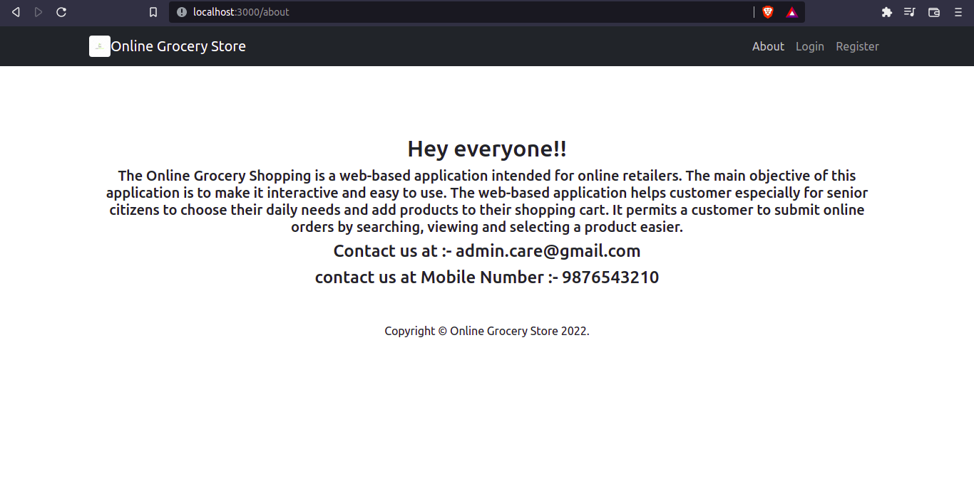

Figure 4. About Page

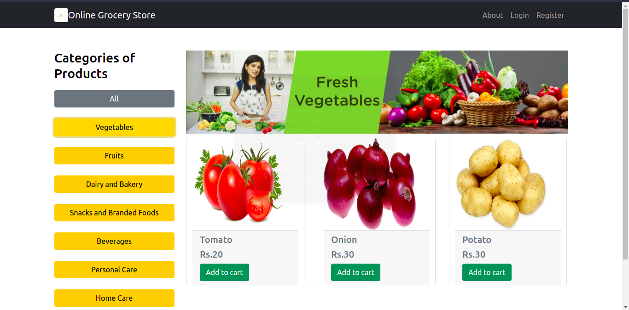

Figure 5. Product Category

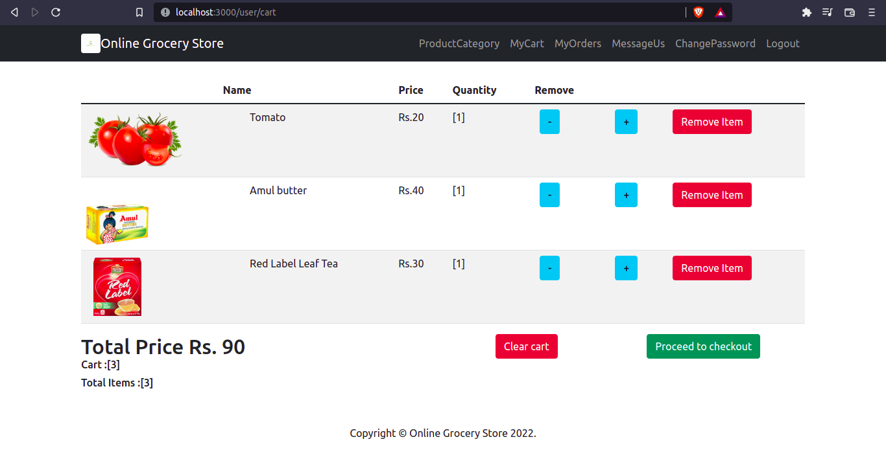

Figure 6 . My Cart

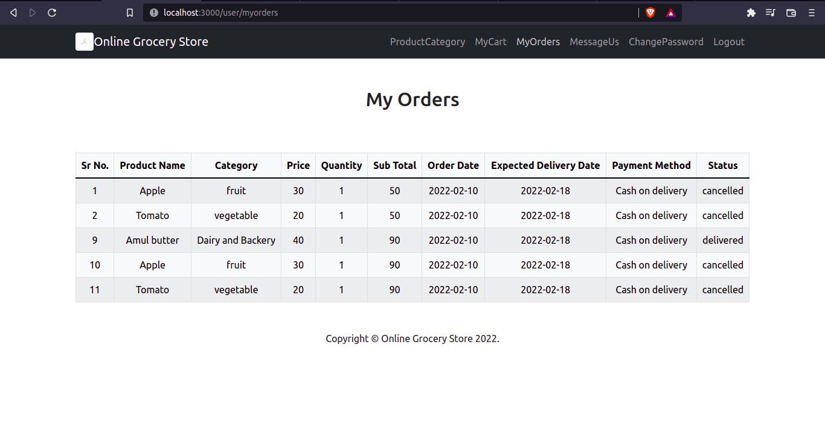

Figure 7. My Orders

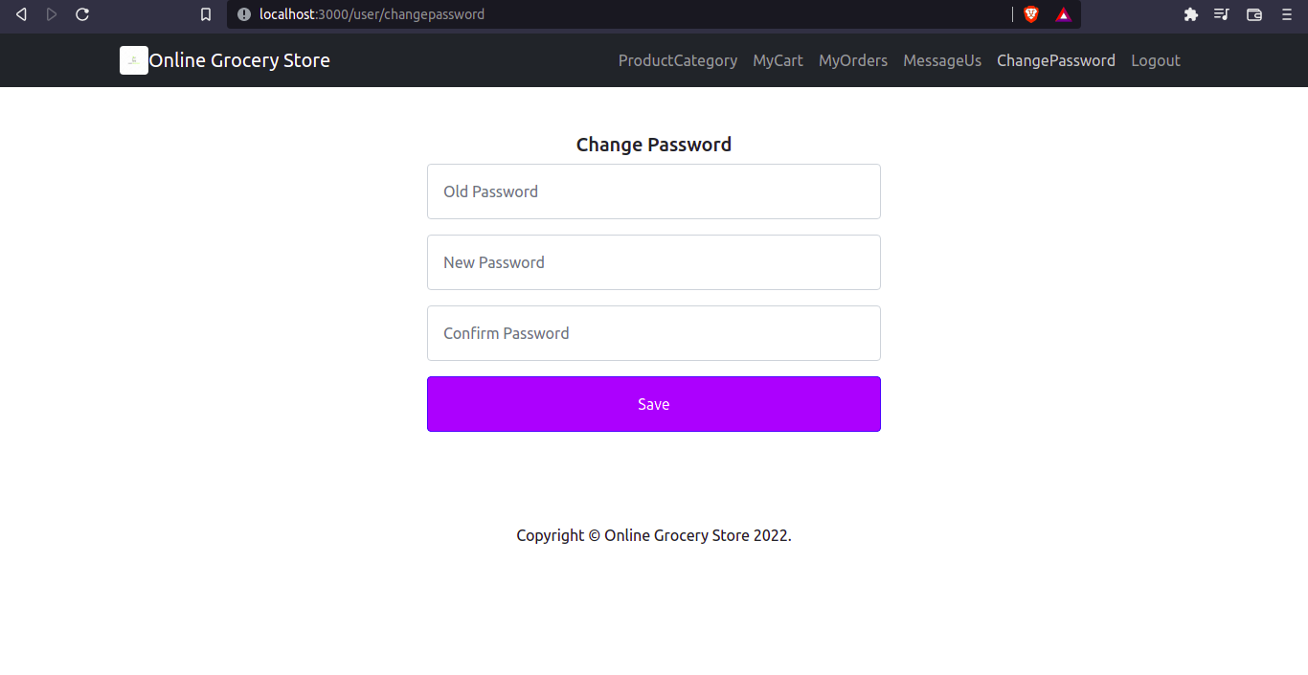

Figure 8. Change Password

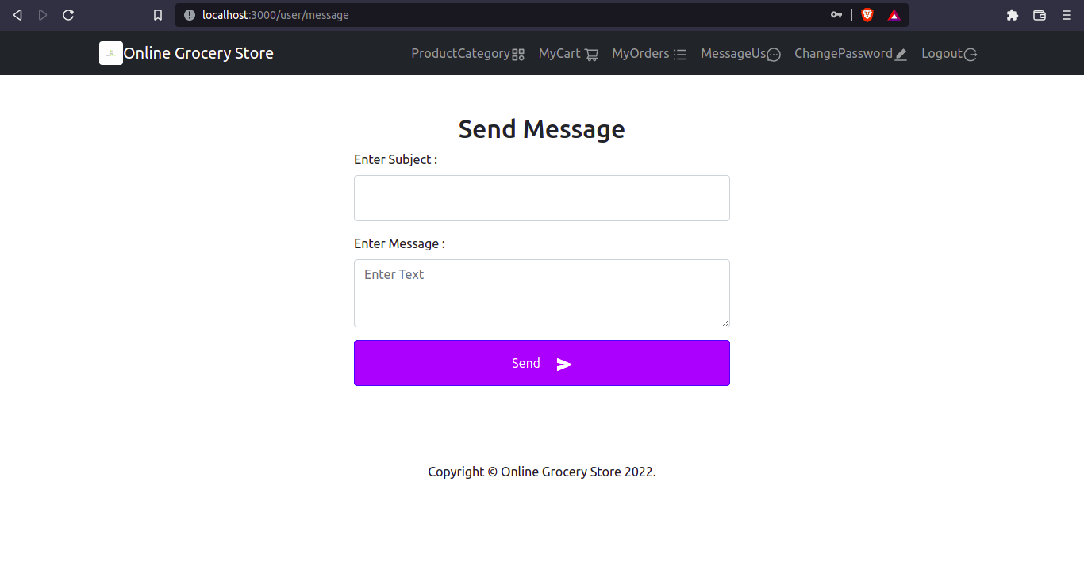

Figure 9. Feedback

**Admin**

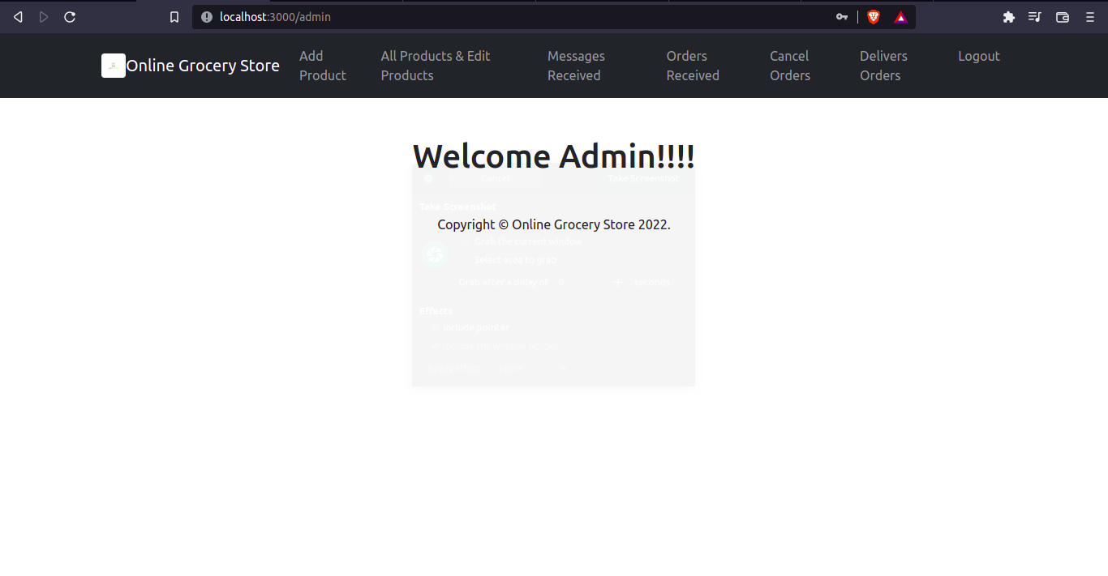

Figure 10. Welcome page of Admin

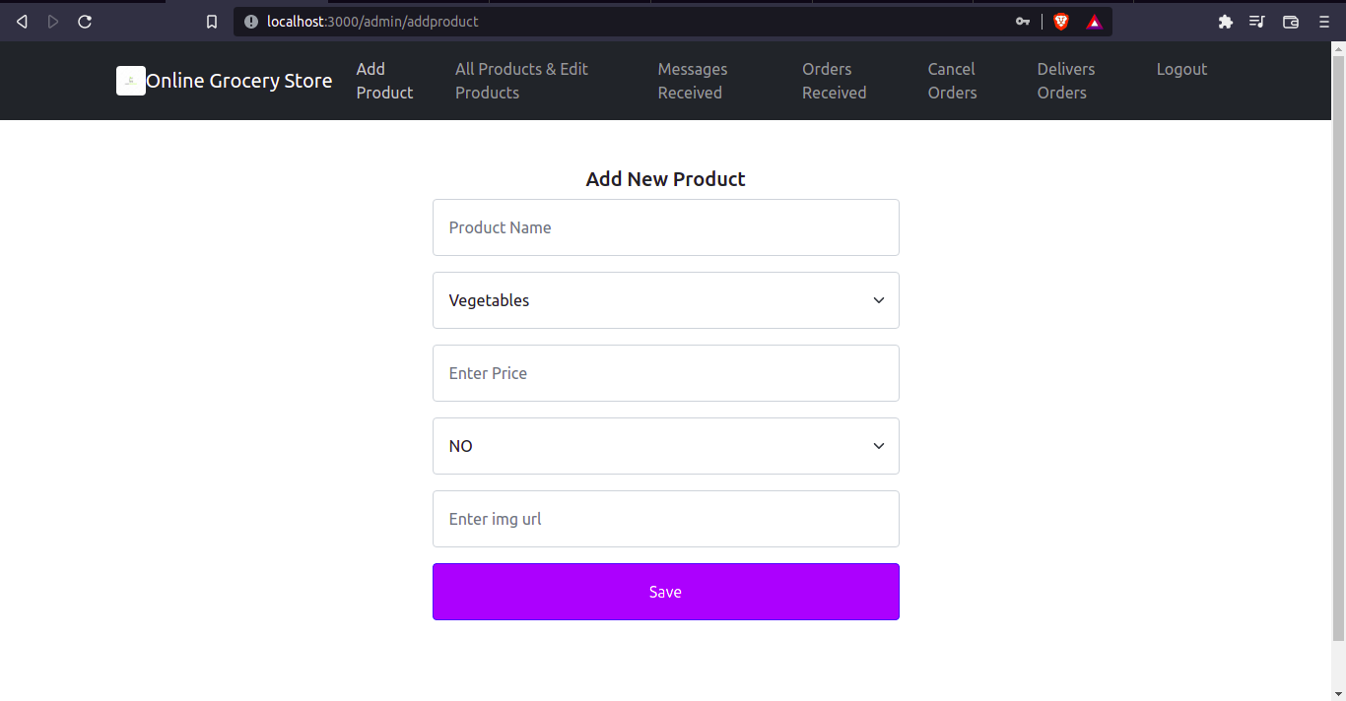

Figure 11. Add new products

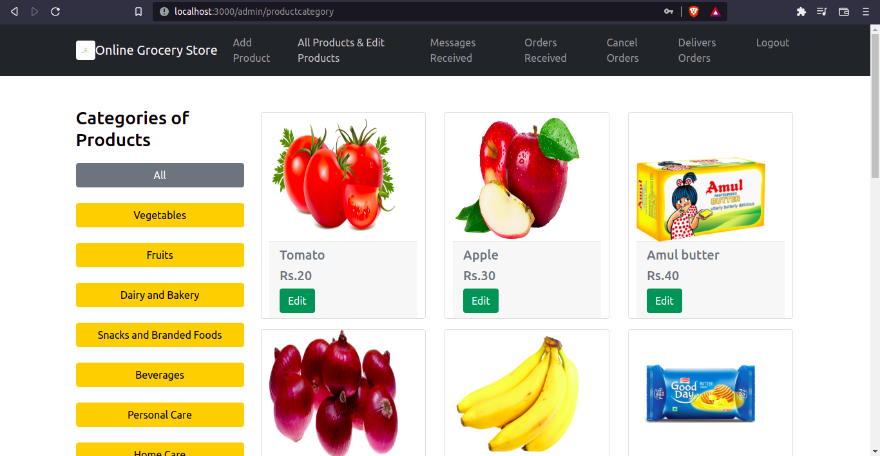

Figure 12. All products

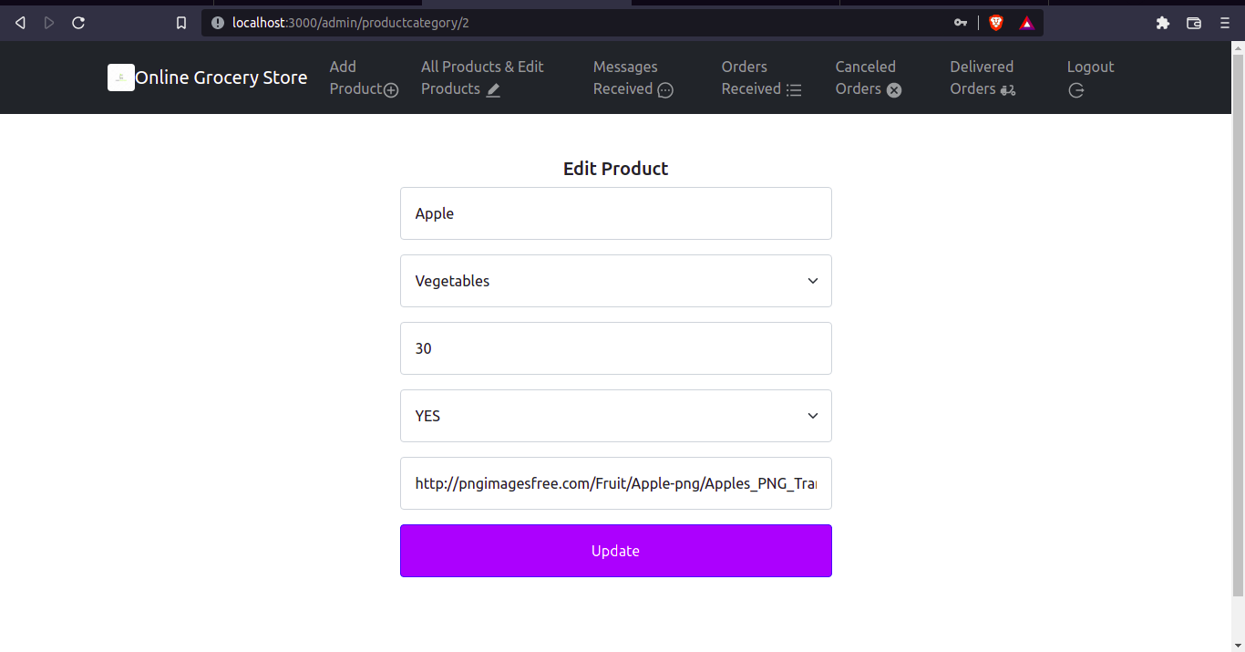

Figure 13. Edit products

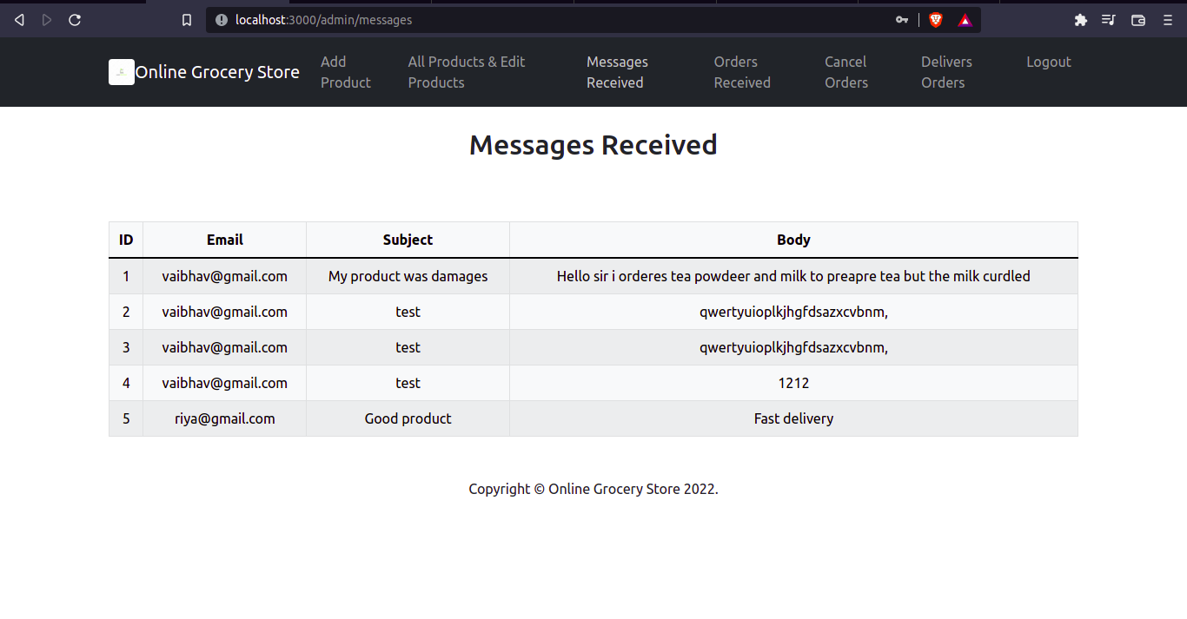

Figure 14. Message Received from user

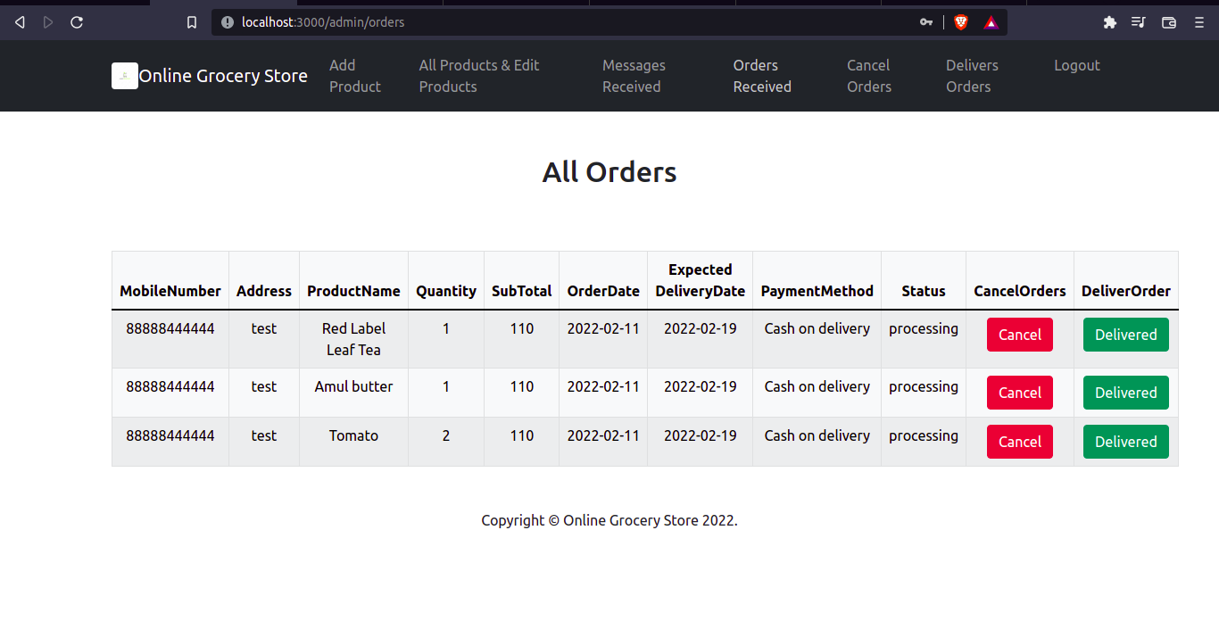

Figure 15. Orders received

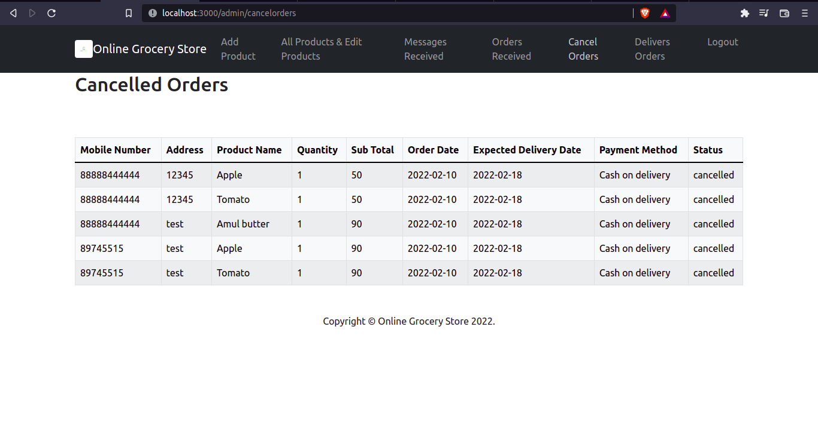

Figure 16.Cancelled Orders

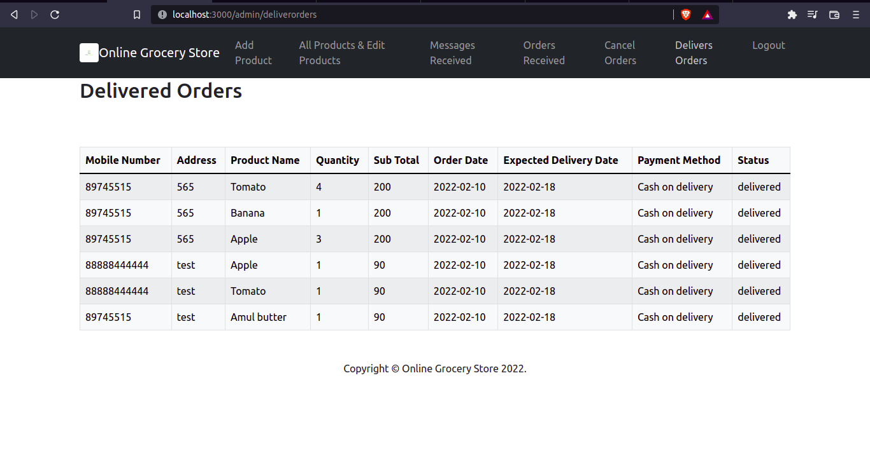

Figure 17. Delivered Orders